System Requirements Specification

Version History
Version No. | Short Description of changes | Release Date | Release by | Approved by
1.0 | Initial version | 10/06/2022 | Nayan Patel | Dheeraj Mohanbabu,  Steve Anderau,  Ethan Pelligrini,  Nayan Patel
1.1 | Added use cases in section 6 | 10/10/2022 | Nayan Patel | Dheeraj Mohanbabu,  Steve Anderau,  Ethan Pelligrini,  Nayan Patel

Table of Contents
1 Introduction 3
1.1 Purpose/Scope 3
1.2 Use of this document 3
1.3 References 3
2 Glossary 3
3 User Requirements 3
4 Systems Architecture 3
5 Systems Requirements 4
5.1 Functional Requirements 4
5.1.1 Graphical User Interface (GUI) 4
5.1.2 Web Scraper 5
5.1.3 Product Attribute Comparator 5
5.2 Non-functional Requirements 5
6 Use Cases 6
7 Appendix 8

Introduction

Purpose/Scope
This document defines the functional and non-functional requirement for the Application that the S.E.N.D. team is building.

Use of this document
This document is intended to be used by the system architect, software developers and the test engineers.

References
Not Applicable

Glossary
Following technical terms are used in this document:
Term/Abbreviation/Acronyms | Definition/Meaning
App or app | Application
UI | User Interface
GUI | Graphical User Interface
IDE | Integrated Development Environment
SP | Single Precision datatype

User Requirements
The system shall be able to meet following user requirements:
- The GUI shall accept a keyword or keywords from the users
- Once the system returns the search results, the GUI shall display the list of product name and its attributes (price, rating, etc.) from each marketplace store on the Search Results section
- The GUI displays the option to sort the result list by desired attribute
- The sorted result list is displayed on the same or a new GUI

Systems Architecture
Following context diagram depicts the systems architecture:
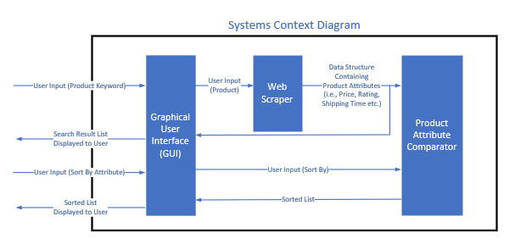
The system will have 3 major functional blocks:
- Graphical User Interface (GUI): It provides interfaces for the user to input and system to display the results
- Web Scraper: Based on the user input, it scrapes the marketplace websites and returns product attributes
- Product Attribute Comparator: It sorts the search results based on the input from the user

Systems Requirements

Functional Requirements
The system shall be able to meet following functional requirements:

Graphical User Interface (GUI)
- The entry of user input shall be through a GUI
- The system shall take input from the user in the form of a keyword for searching the item
- The user input keyword will be passed to the web scraper block
- The GUI shall be able to display the list of search results from different marketplace sites
- It shall provide an option to get an option from the user if it needs the result list sorted
- It will display the sorted list

Web Scraper
- The web scraper block receives input from the GUI for the user entry for product keyword search
- It will launch all the marketplace sites one at a time
- For each marketplace site, it will enter the keyword in the search box, click the search button and wait for the search results
- Once the search results are returned, it will pick the best matching item from the list and get the URL from the html scraping
- Using the URL, it shall open the page and scrape the product attributes, like price, rating, shipping time etc.
- Once collected the product attributes from one site, it will repeat the same process for other marketplace sites
- It creates a data structure containing product info from different sites
- It passes this data structure to Item Attribute Comparator and GUI blocks

Product Attribute Comparator
- The Product Attribute Comparator block receives the product info data structure from Web Scraper block
- Based on the user input that tells what attribute to use to sort the search results, it will sort the list
- The sorted list will be sent to the GUI

Non-functional Requirements
- The “keyword search” can contain any alphanumeric characters with no length limitation. It cannot contain special character (e.g., !, @, #, $, % etc.)
- The GUI text box for search option shall be wide enough for getting all the characters entered by the user
- The GUI search shall have a Click or Enter button option once the keyword is entered
- The web scraper shall pause for a minimum time (3 sec) before each automatic action on a marketplace site
- The product name and other attributes in search result list (sorted and unsorted) shall be processed and displayed with right data type for maintaining the best accuracy possible. For example, the price and rating shall be in Single Precision data type.
- Also, if SP datatype is used, the number of digits followed by decimal points shall be accordance with the display in the marketplace site. For example, the price will have 2 digits and rating will have 1 digit after the decimal point
- The sorted and unsorted result list is displayed in a tabulated form for the ease of the user to read

Use Cases
System Use case Diagram:
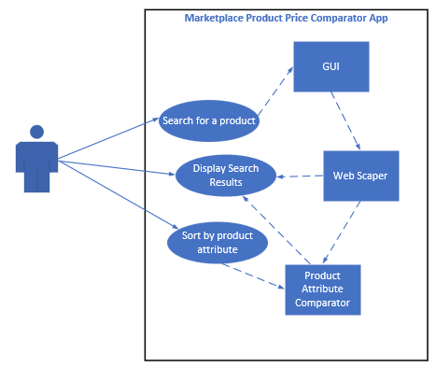

Use case 1:
Use Case Name | “Search for a product”
Actor | Customer – a user of the app
Assumptions | The system providing an interface to enter search keyword
Pre-conditions | The search box in the GUI is available and empty to be able to enter search keyword
Initiation (triggering event) | This use case starts when the user enters the keyword for searching a product and clicks on Search button or hit Enter (Return)
Main flow of events | - The GUI read the keyword and passes that to Web Scraper subsystem  - The Web Scraper subsystem opens each market place site one after another and makes a search with that keyword  - Once the results are displayed, using the best match, it returns products attributes
Exceptional flow of events | - The system returns the attributes of the product that does not match with customer’s expectations
Post-conditions | Customer receives the compared list of attributes of the desired product

Use case 2:
Use Case Name | “Display Search Results”
Actor | Web Scraper subsystem
Assumptions | The system providing an interface to request displaying search results
Pre-conditions | - The search result fields (in a table form) in the GUI is available  - The web scraping of the product attributes from all the marketplace sites are complete
Initiation (triggering event) | This event starts when all the search results from all the marketplace sites are available
Main flow of events | - The Web Scraper subsystem sends the search result list to the GUI for the display  - The GUI displays the search results in a tabulated form
Exceptional flow of events | - Some search result text exceeds the respective field size and cannot be displayed completely
Post-conditions | The list of product attributes along with the names of the marketplace sites (un-sorted list) is displayed on the GUI

Use case 3:
Use Case Name | “Sort by product attribute”
Actor | Customer – a user of the app
Assumptions | The system providing an interface to select sorting option and a way to choose what attribute is to be used for sorting
Pre-conditions | The process of search results availability and displaying on the GUI is complete
Initiation (triggering event) | This use case selects the attribute for sorting
Main flow of events | - The GUI read the selected attribute and passes that to Product Attribute Comparator subsystem  - The Product Attribute Comparator subsystem sorts the search result lists and passes the sorted list to GUI  - The GUI empties the search results display area and display the sorted results
Exceptional flow of events | - None
Post-conditions | Customer receives the sorted search result list

Appendix
None

